Q1  Write a program to calculate the sum of first 10 natural number.

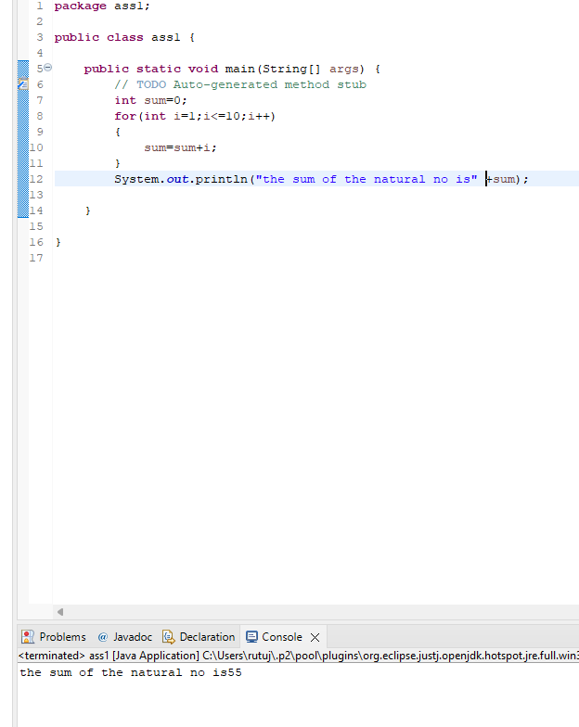

Q2 Write a program that prompts the user to input a positive integer. It should then print the multiplication table of that number.

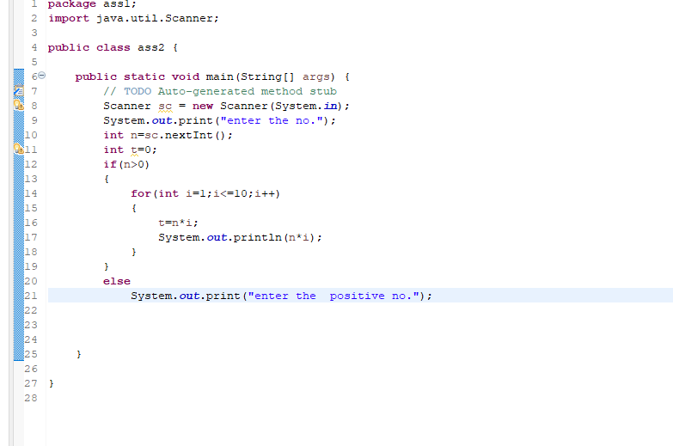

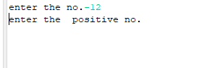

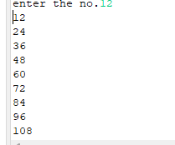

Q3 Write a program that prompts the user to input an integer and then outputs the number with the digits reversed. For example, if the input is 12345, the output should be 54321.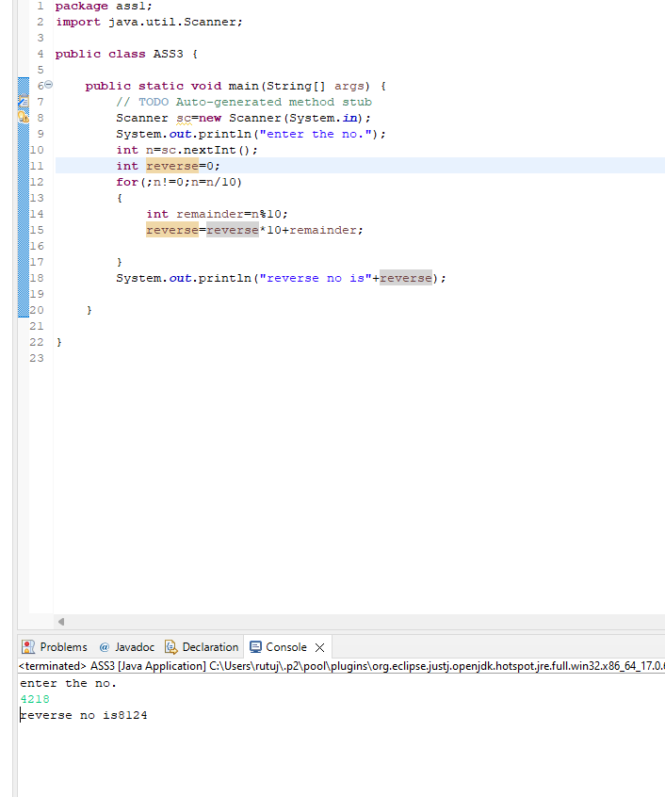

Q4 Write a do-while loop that asks the user to enter two numbers. The numbers should be added and the sum displayed. The loop should ask the user whether he or she wishes to perform the operation again. If so, the loop should repeat; otherwise it should terminate.(while loop)

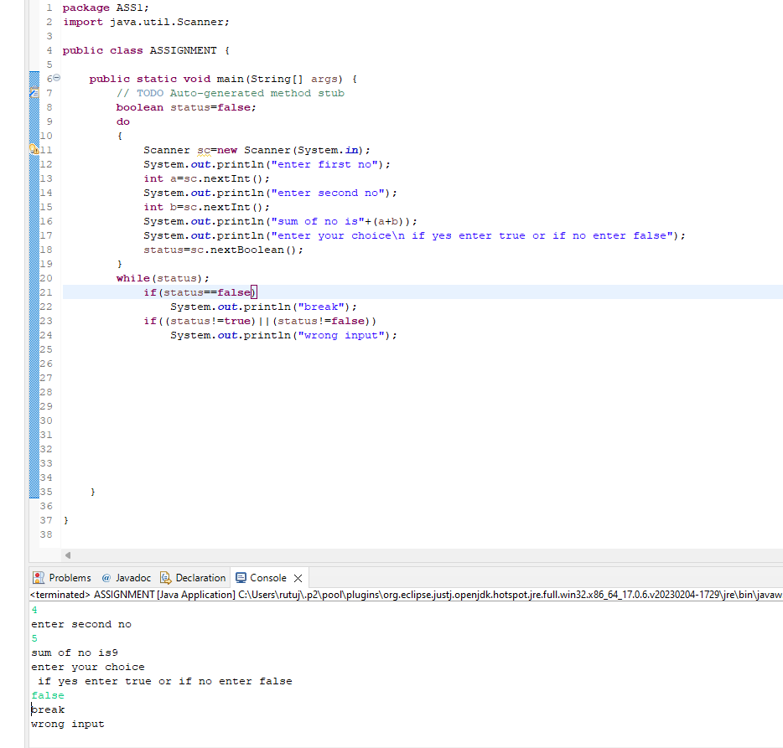

Q5 Write a program to print out all Armstrong numbers between 1 and 500. If sum of cubes of each digit of the number is equal to the number itself, then the number is called an Armstrong number.  
For example, 153 = ( 1 \* 1 \* 1 ) + ( 5 \* 5 \* 5 ) + ( 3 \* 3 \* 3 )

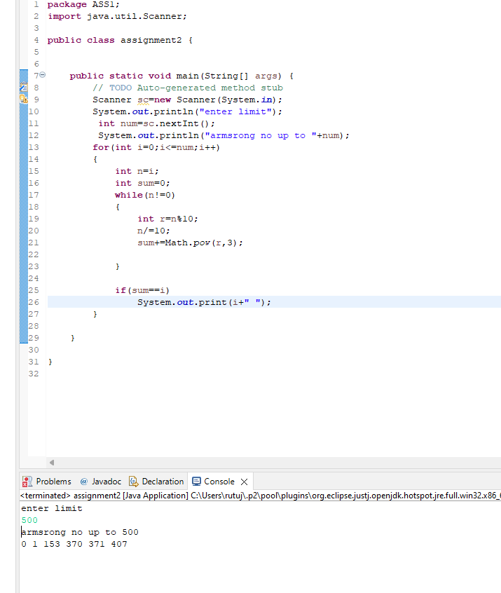

Q6 Write a program to print Fibonacci series of n terms where n is input by user :  
0 1 1 2 3 5 8 13 24 .....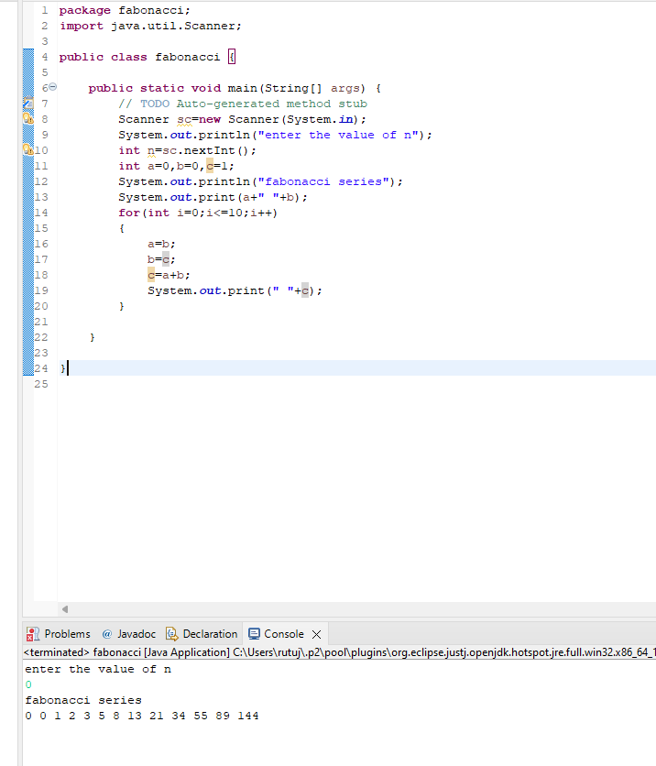

Q7 Write a program to print following :

1.

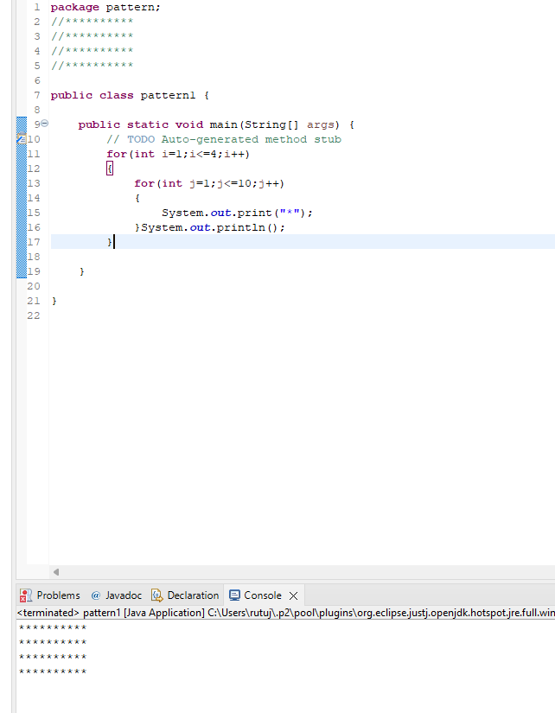

2.

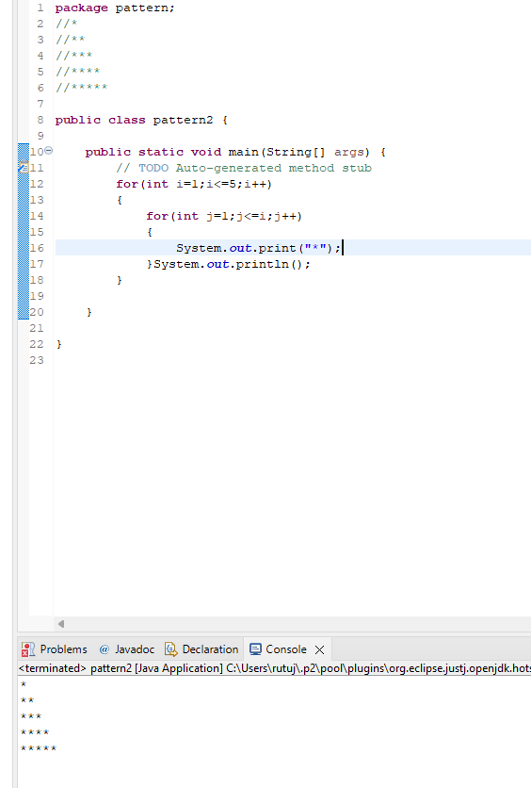

3. 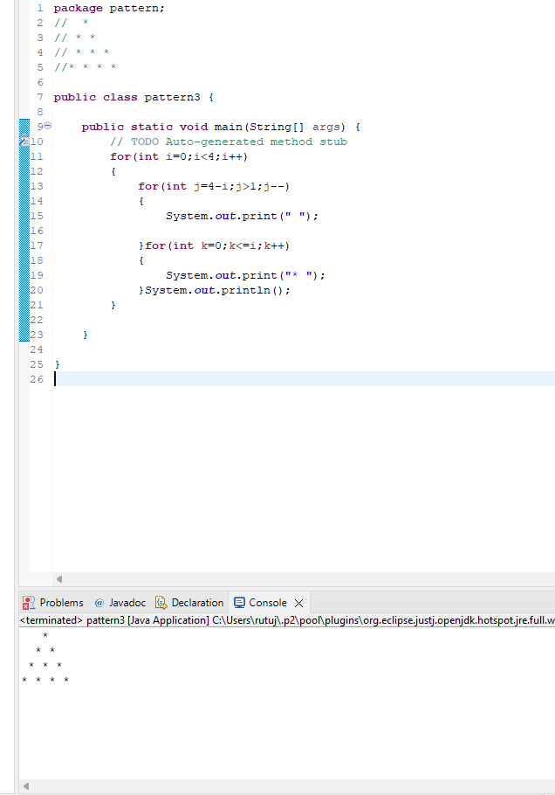

4. 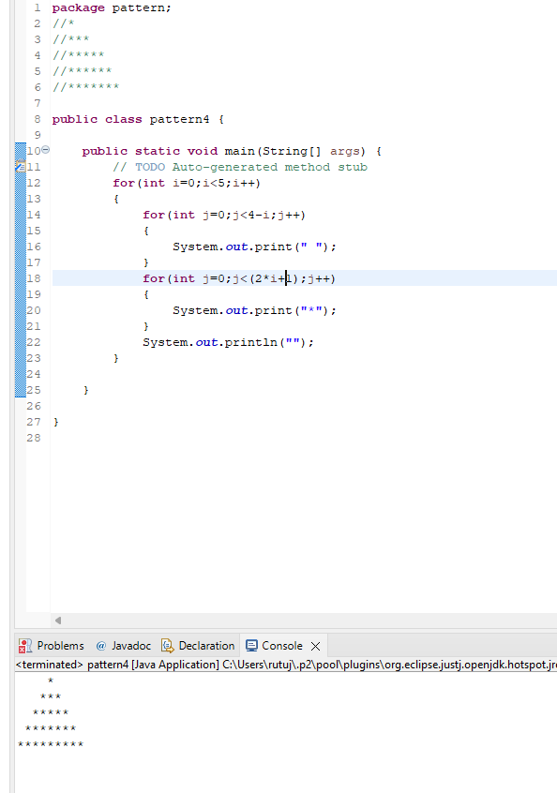

6. 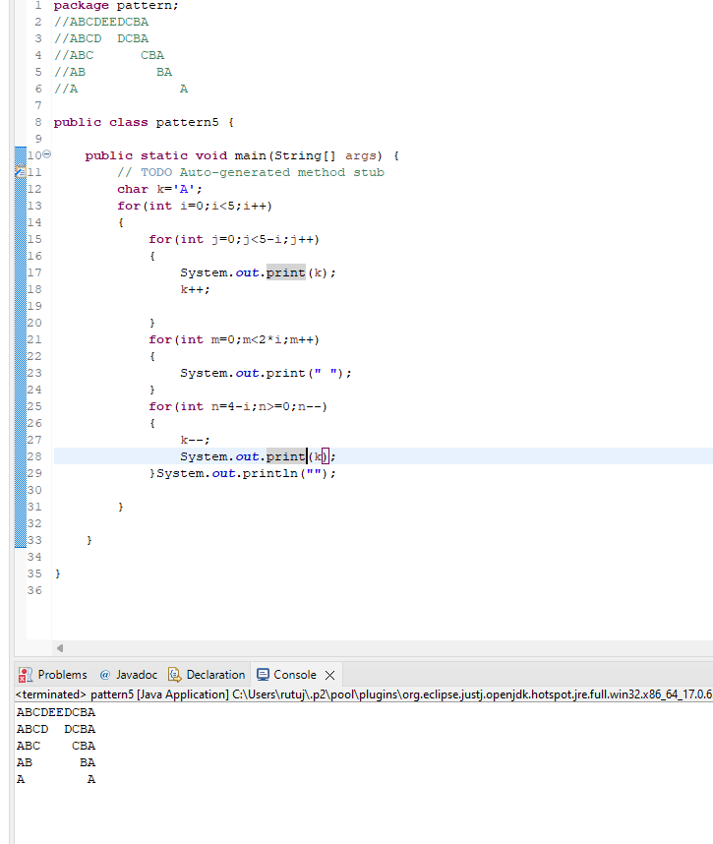

Q8 Write a program in java to find the sum of the even and odd digits of the number which is given as input.

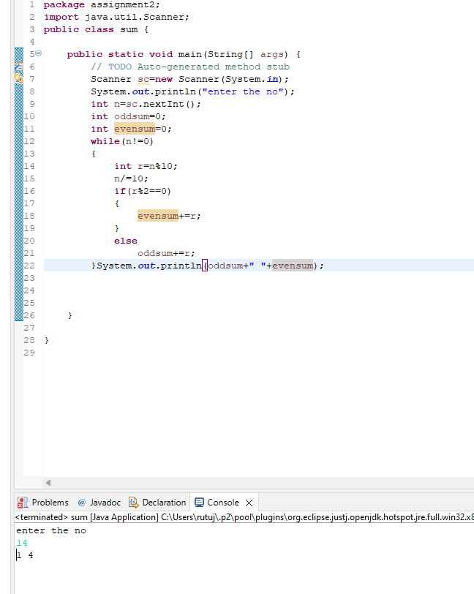

Q9 Write a program to check if given number is prime or not

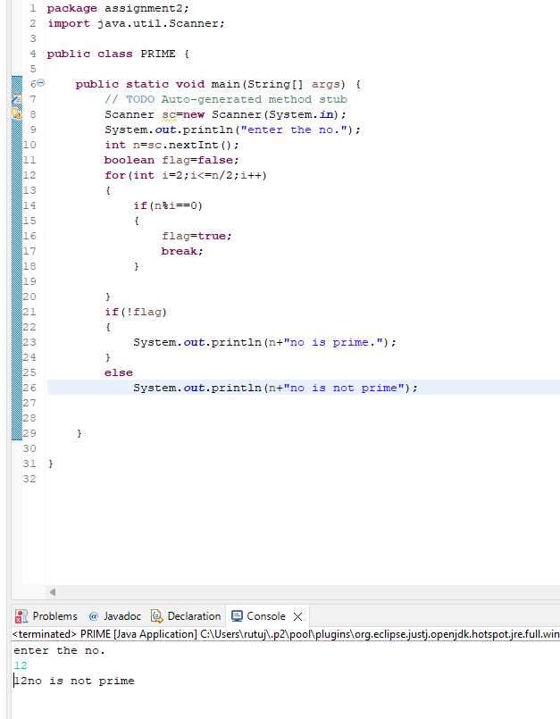

Q10 write a program to print prime numbers between 2 to 20.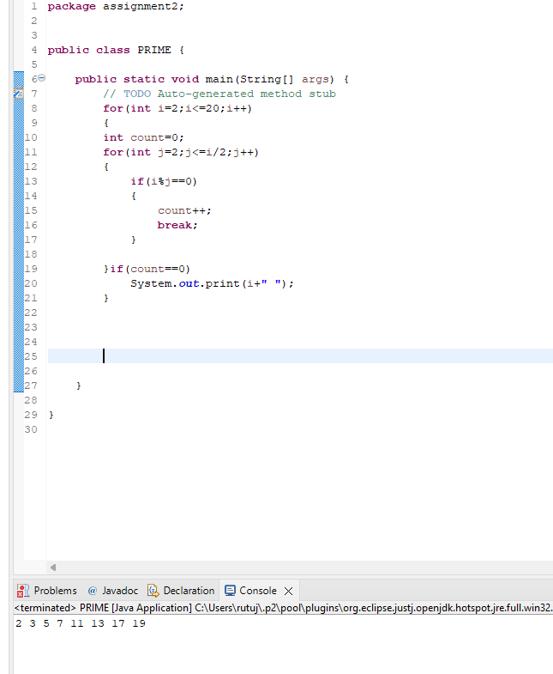

Q11 Write program to find largest among three numbers

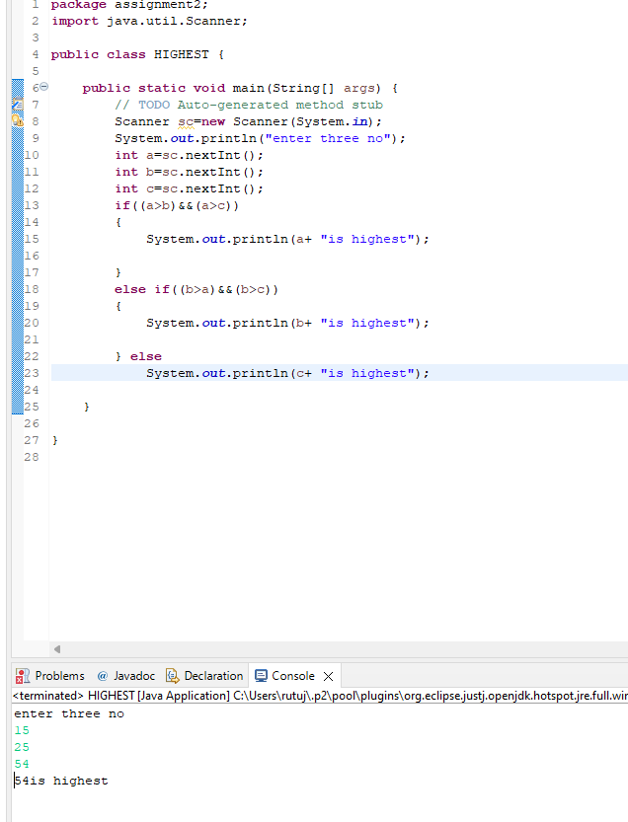

Q12 Write a program to find sum of all integers greater than 100 and less than 200 that are divisible by 7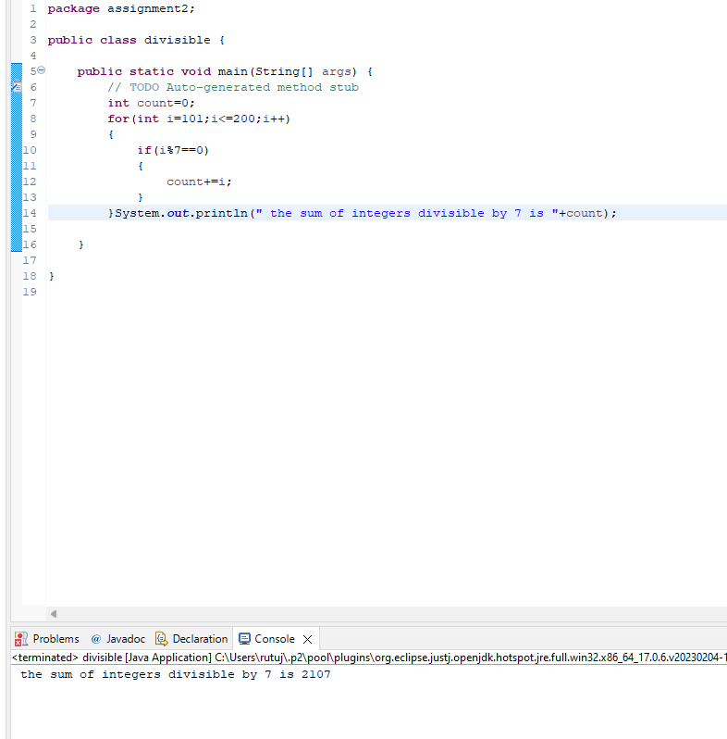

Q13  Write a Java program to print numbers between 1 to 100 which are divisible by 3, 5 and by both.  
Hint  
            System.out.println("\nDivided by 3: ");          
       for (int i=1; i<100; i++) {  
           if (i%3==0)  
           System.out.print(i +", ");            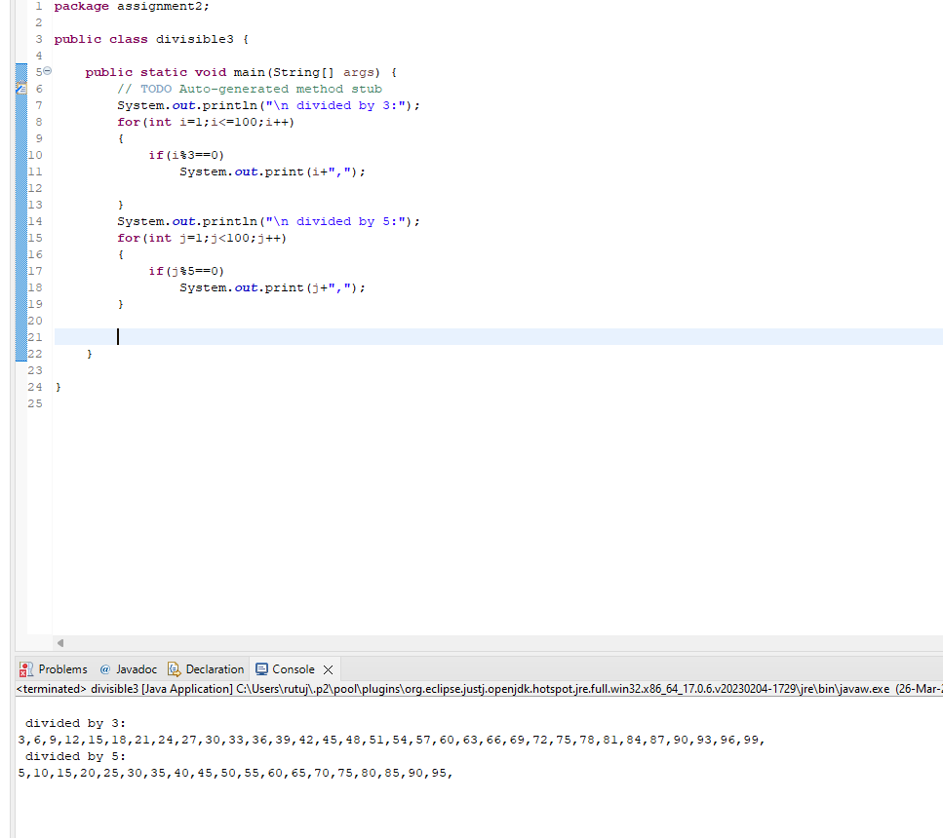

Q14 create a menu driven application in java that show  
   "Add"        Add two number  
  "subtract"  Subtract two number  
  "Multiple"    Multiple two numbers  
  "Exit "           Exit  
  
Ask two numbers from user  and as per user choice perform necessary action using switch command

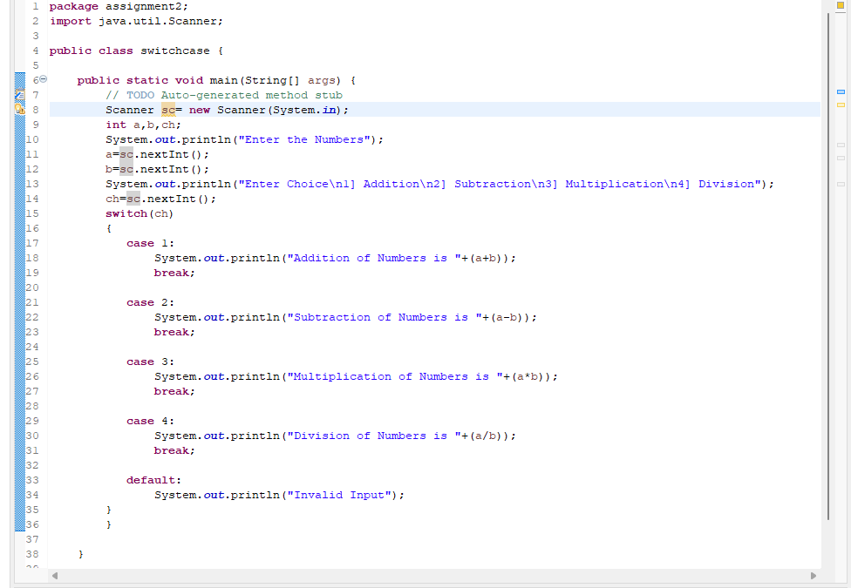

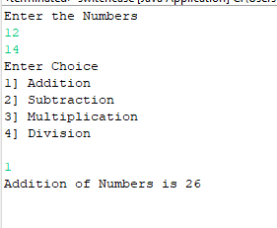

Q15 Write a program to display first 1 to 20  even number on screen . Terminate the program when number 16 is found using break command .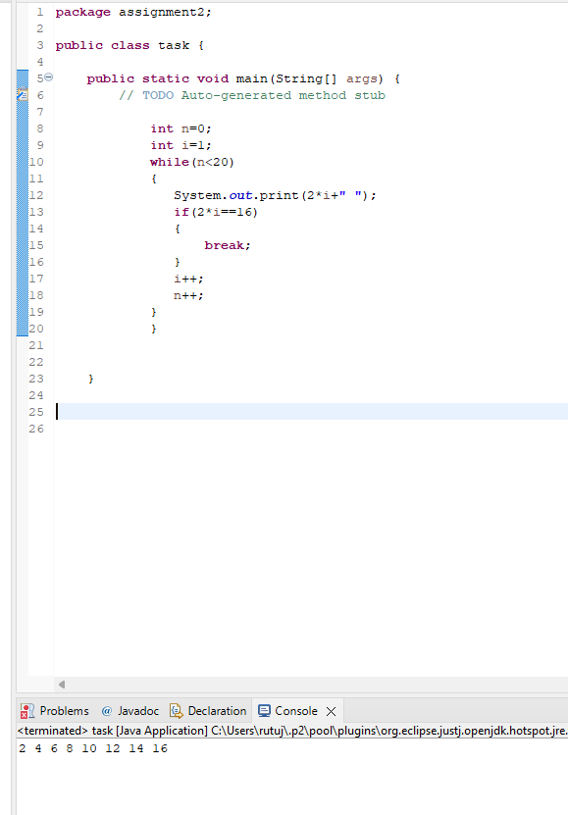

Q16 Write a Java program that accepts two double variables and test if both strictly between 0 and 1 and false otherwise.  
Hint n1 > 0 && n1 < 1 && n2 > 0 && n2 < 1

